# **University at Buffalo**

# **Department of Computer Science and Engineering**

**CSE 473/573 – Computer Vision and Image Processing**

# **Spring 2020**

**TuTh 9:30AM - 10:50AM**

**Project #2 Submission Guidelines**

**When to submit?**

* By 4/9/20, 11:59PM No Excuses! (Extended from 4/2/20)

**Where to submit?**

* Please submit to both **UBlearns** and **AutoLab**.

**Files to be submitted to UBLearns:**

* The code and photos are stored in a single file whose extension is “zip”.
* The code you provide should be stored in a folder named “src” and the python file shall be named as stitch.py
* The photos you take for the bonus should be stored in a directory “ubdata”
* The photos you take for the bonus named “ub*.jpg”. where * is a single digit 1-9 (the images can be stored in any order).
* After changing the working directory into the folder that contains your code, the grader should be able to run your program to stitch the photos in either of the datasets using the command “python stitch.py [data directory]”.
  + E.g. python ./src/stitch.py ‘./ubdata’ or python stitch.py ‘../ubdata/’, please try to use os.path.join() to process directory in order to make your code cross platform compatible;
  + Please make sure the directory parameter can take either **absolute directory or relative directory.**
* The program should read ALL jpg files in the data directory and stitch them together, no matter what they are named, as long as they have a jpg extension.
* The panoramic photo your program creates should be saved to the same directory as the data and be called “panorama.jpg”
  + Please include the “panorama.jpg” in each of the folder you submitted
* The zip file shall be named as ########.zip, the 8 digits shall be your UB person number. Below is an example of the submission folder directory:

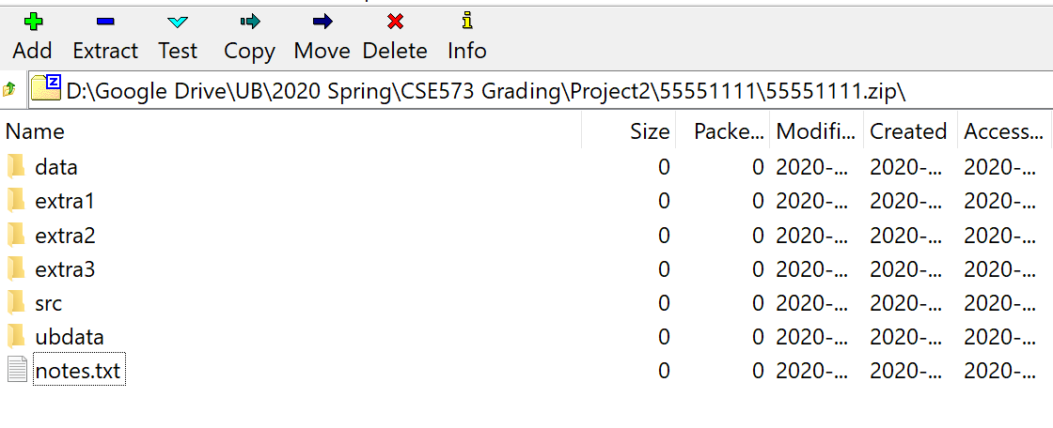

*Description of the folders:*

|  |  |
| --- | --- |
| Folder Name | Description of contents |
| data | test files from piazza |
| ubdata | bonus images |
| src | stitch.py |
| extra# | Additional samples you want to show, that show additional challenges that are not otherwise demonstrated [Optional] |
| Notes.txt  (**Only required if your script takes long time to run**) | If your code takes significant amount of time to stitch images, (e.g. takes more than 20mins to stitch 2-3 images (500-800 in pixel width/height each), please put a note in the notes.txt file to describe how long will your code take to finish stitching. |
| Note: Please ensure that we can see those folders/files directly upon extraction of your zip file, do not create any unnecessary parent folders. [Hint: you can achieve this by selecting all files/folders to be submitted and then right click - compress to zip - rename to xxxx.zip] | |

**Files to be submitted to AutoLab:**

* Only the SINGLE [stitch.py] python file should be uploaded to AutoLab.

Notes:

* Your grade will be ZERO if the python script submitted to UBLearns and AutoLab are different.
* Code clarity and proper comments is strongly encouraged (will be graded as part of item 1 in the rubric).
* All of your code must be in one python file [stitch.py].

**Rubric:**

* Overall code and approach + optional extra challenges 40 pts
* Processing test images from piazza 30 pts
* Processing set of images to be supplied by grader 30 pts
* Bonus 15 pts (extra credit)